Report of | Meeting | Date
Director of Finance and Section 151 Officer | Governance Committee | Tuesday, 26 July 2022

Is this report confidential? | No

CIPFA RESILIENCE INDICATORSCIPFA Resilience Index 2020/21
Is this decision key? | No

Purpose of the Report
- To present to the Governance Committee the latest CIPFA Resilience Index (2020/21) compared to the previous published index (2019/20).

Recommendations to Governance Committee
- The Governance Committee is asked to note the index and the continued strong position of the Council.

Reasons for recommendations
- The index compares key financial indicators with other Local Authorities and the results are intended to provide assurance to the Governance Committee.

Other options considered and rejected
- Not applicable.

Corporate priorities
- The report relates to the following corporate priorities: (please bold all those applicable):

An exemplary council | Thriving communities
A fair local economy that works for everyone | Good homes, green spaces, healthy places

Background to the report
6. An online tool was released by CIPFA (Chartered Institute of Public Finance and Accountancy) in December 2019 to show the levels of financial resilience of each local authority across England.
7. The Tool is intended to help to ensure the sector is held to collective and robust standards of governance and financial management.
8. Indicators used in the Index include levels of reserves, external debt and ratios of income and expenditure.
9. These measures are intended to provide a rounded picture of an authority’s resilience to financial shocks.
10. Whilst the Tool is intended to support local authorities in conducting their long term resilience assessments it is important to remember that the Index forms only one part of that judgement. Local context must also be taken into account when forming an overall picture of resilience.
11. The index is based upon statistical returns submitted by Local Authorities and it should be recognised that data quality / consistency will be an issue as different organisations will undoubtedly have different approaches.
12. The index is valid however in making overall comparisons and comparing trends between years.
13. CIPFA have now released the 2020/21 index; this is analysed in the report and compared against the 2019/20 data.
THE INDICATORS
14. The 8 indicators applicable to District Councils are as follows;
INDICATOR | DEFINITION
Reserves Sustainability Measure | Ratio between the current level of reserves and the average change in reserves in each of the past 3 years.  A negative value (which implies reserves have increased) or one greater than 100, have been recoded to 100).  (A higher figure indicates stronger resilience)
Level of Reserves | Ratio of current level of reserves to the council’s net revenue expenditure.  (A higher figure indicates stronger resilience)
Change in Reserves | Average % change in Reserves over the past 3 years  (A higher, positive figure indicates stronger resilience)
Interest Payable / Net Revenue Expenditure | Ratio of Interest Payable to Net Revenue Expenditure  (A lower figure indicates stronger resilience)
Gross External Debt | Compares gross external debt held by a council
Fees and Charges to Service Expenditure Ratio | Proportion of fees and charges against the council’s total service expenditure  (Measures dependency on fees and charges and also how effective the council has been in generating income in this way)
Council Tax Requirement/Net Revenue Expenditure | Ratio of council tax as a proportion of net expenditure  (Measures dependency on Council Tax and how effective the council has been in moving away from dependency on grants and funding from central government)
Growth Above Baseline | Difference between the baseline funding level and retained business rates income, over the baseline funding level
ADDITIONAL INDICATOR
Auditors VfM Assessment | This was published for 2019/20; however is not included in the 2020/21 index

SOUTH RIBBLE PERFORMANCE
15. The indicators are available for all authorities in the country and can be selected individually or by reference to;
- Upper Tier or Lower Tier and then by,
- County Councils/ London Boroughs/ Metropolitan Districts/ Non-Metropolitan Districts/ Unitaries OR Nearest Neighbour
16. For the purposes of comparison, South Ribble has been compared to their “Nearest Neighbours”. The CIPFA Nearest Neighbour Model adopts a scientific approach to measuring the similarity between authorities taking into account a range of economic, social and physical characteristics.
17. The Nearest Neighbour Grouping has been revised in the 2020/21 index and is now as follows;

Amber Valley Braintree Broxtowe
Chorley East Northamptonshire Erewash
Gedling High Peak +Hinckley & Bosworth
Kettering Lichfield Newark & Sherwood
Rossendale South Derbyshire South Kesteven
South Ribble +Stafford Stroud
18. The indicators are outlined in the attached charts; with comparison to the 2019/20 position.
19. It should be noted that on some graphs the scale has changed between the two years.
CONCLUSION
20. There has not been a significant shift in either the scale of the Council’s indicators, or their position in the “rankings” of the comparator Group.
21. The indicators continue to highlight the Council is in a strong position.
22. The indicators highlight a low level of borrowing for the Council however a number of major schemes now feature in the capital programme which will see this increase e.g. Jubilee Gardens Extra Care scheme, and improvements to Leisure facilities.

Climate change and air quality

- The work noted in this report does not impact the climate change and sustainability targets of the Councils Green Agenda and all environmental considerations are in place.

Equality and diversity
- Not applicable

Risk
- The analysis provides assurance that the Council is in a strong financial position and resilient to financial risks.

Comments of the Statutory Finance Officer
- There are no direct financial implications arising from this report.

- The report presents the financial standing of the council based on the figures included in the 2020/21 statutory returns for South Ribble in comparison to a group of councils who CIPFA deem, based on similarities across a range of economic, social and physical characteristics, to be the best comparator group.

Comments of the Monitoring Officer
- There are no direct legal implications arising from this report.

Background documents
There are no background papers to this report

Appendices
Appendix A – Comparison of Resilience Indices

Report Author: | Email: | Telephone: | Date:
Steve Kenyon (Interim Deputy Director of Finance) | steve.kenyon@southribble.gov.uk | 01772 625625 | 4th July 2022

APPENDIX A
- Reserves Sustainability Measure

2020/21 | 2019/20
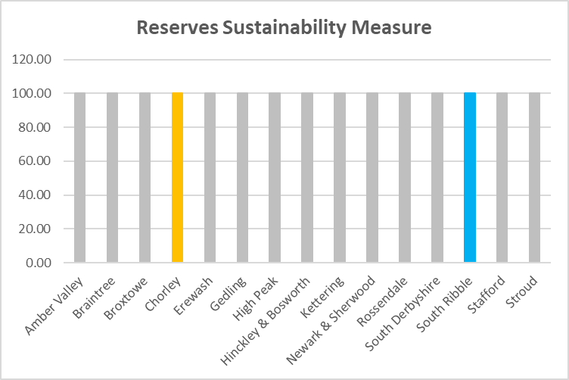 | 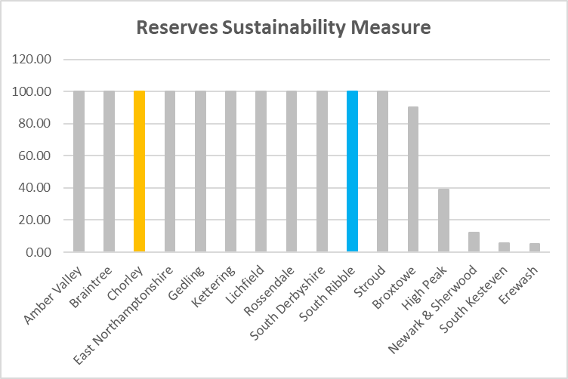

Highlights a strong level of reserves (maximum level on chart), with growth over the last 3 years. It should be noted that some growth will be due to Covid-19 funding unspent / carried forward.

- Level of Reserves

2020/21 | 2019/20
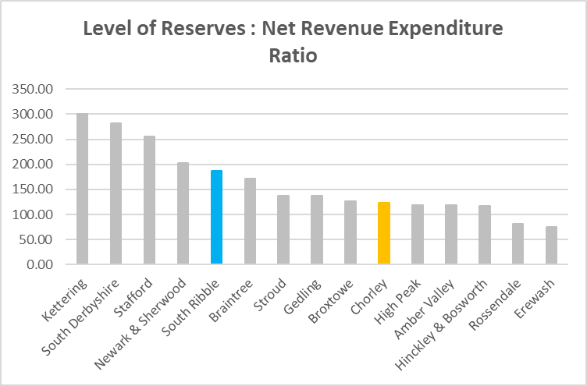 | 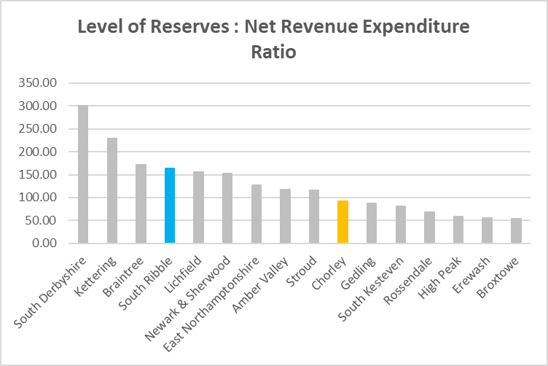

Overall rankings are broadly similar between the two years. The charts highlight the Council has increased reserves since 2019/20; primarily as a result of Covid Funding carried forward.
Of the 180 districts, against this indicator South Ribble holds reserves (Earmarked and Unallocated excluding Covid grants and S31 Business Rate grants) equivalent to 161.8% of it’s annual Net Revenue, ranking them with the 58th highest level nationally.
In comparison to the 12 Districts in Lancashire, South Ribble had the 3rd highest level of reserves compared to net revenue.
- Change in Reserves

2020/21 | 2019/20
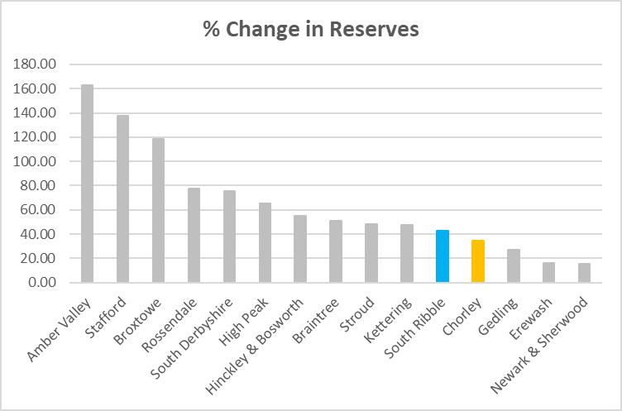 | 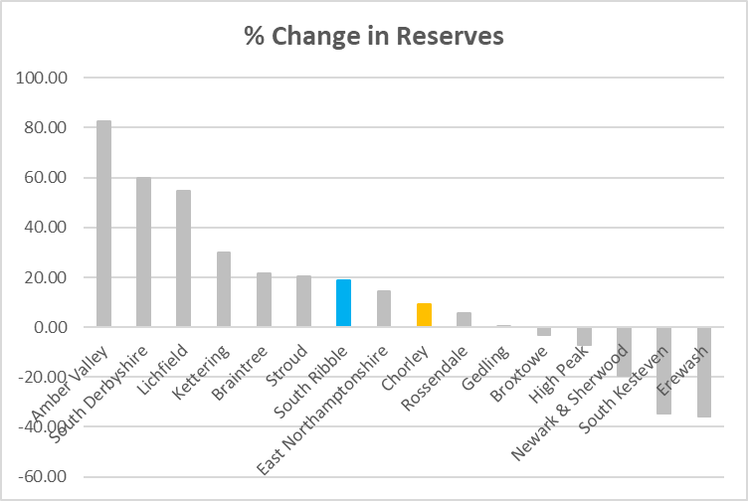

Along with the rest of the Group, the Council displays increased growth in reserves over the last 3 years.

Again, some of this growth will be due to unspent Covid-19 funding at the end of 2020/21.

- Interest Payable/Net Revenue Expenditure

2020/21 | 2019/20
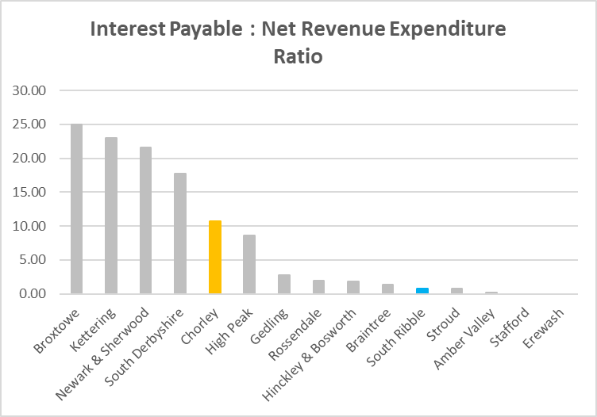 | 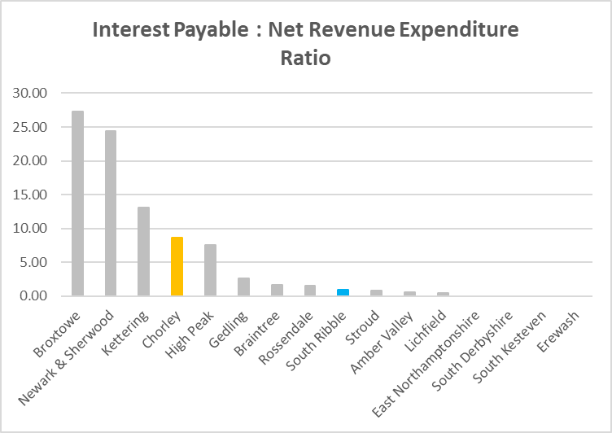

A high level of interest payable compared to Net Revenue Expenditure would be indicative of high levels of borrowing and/or loans taken out at high rates of interest.

The Council continue to display a low figure – however this will increase when planned capital schemes commence (e.g. Jubilee Gardens Extra Care scheme).
Considering the level of Interest Payable as a % of Net Revenue (i.e. as a measure of indebtedness), South Ribble’s Interest payable was 0.72% of it’s Net Revenue ranking them 132nd lowest level of interest payable as a % of Net Revenue across all 180 District councils. In comparison to the 12 Districts in Lancashire, South Ribble had the 4th lowest level of interest payable compared to net revenue.
- Gross External Debt

2020/21 | 2019/20
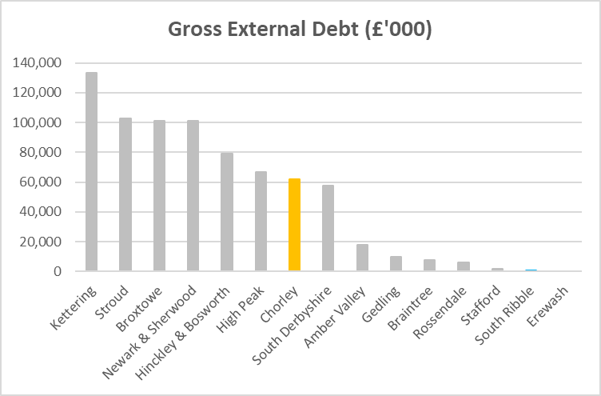 | 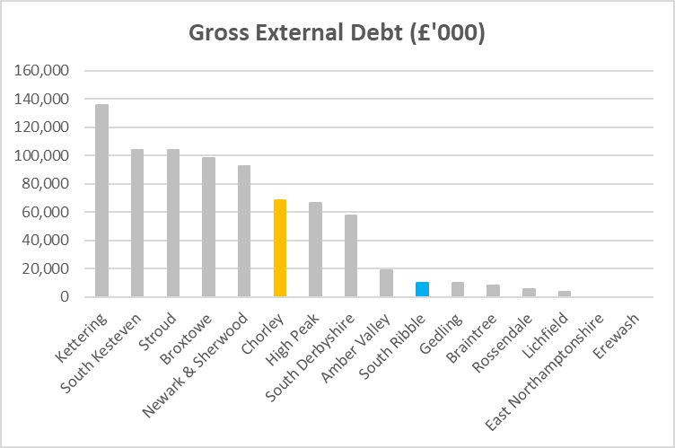

The Council’s debt is currently low, and this is potentially a missed opportunity to undertake improvements in the Borough and generate additional income streams.

This will change when planned capital schemes commence in the Borough, however the charts suggest there is still scope for further investment.

- Fees and Charges to Service Expenditure Ratio

2020/21 | 2019/20
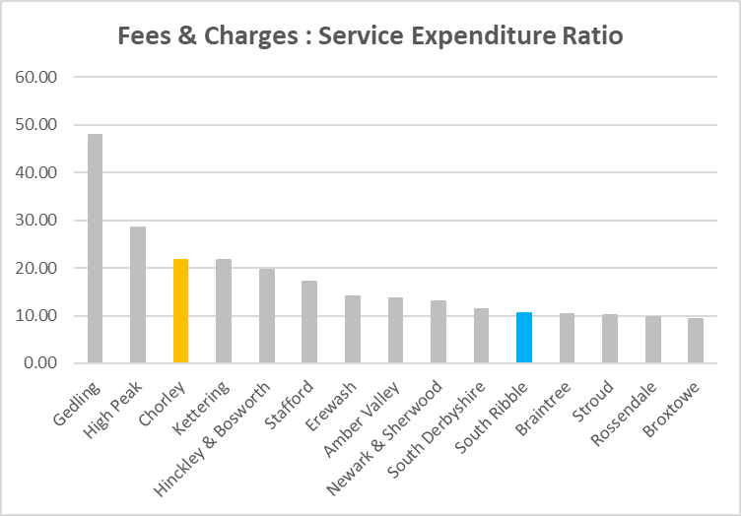 | 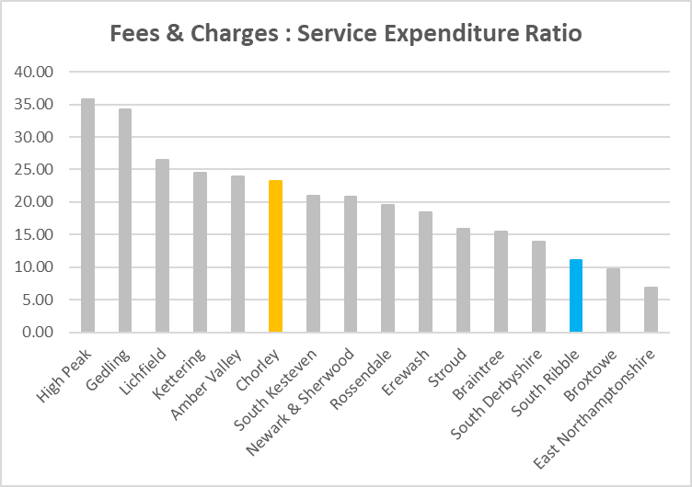

The Council remains towards the lower end of the comparator group however future planned capital investment should see this indicator improve.

- Council Tax Requirement/Net Revenue Expenditure

2020/21 | 2019/20
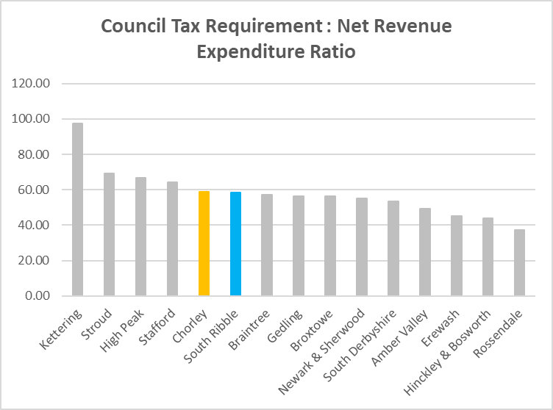 | 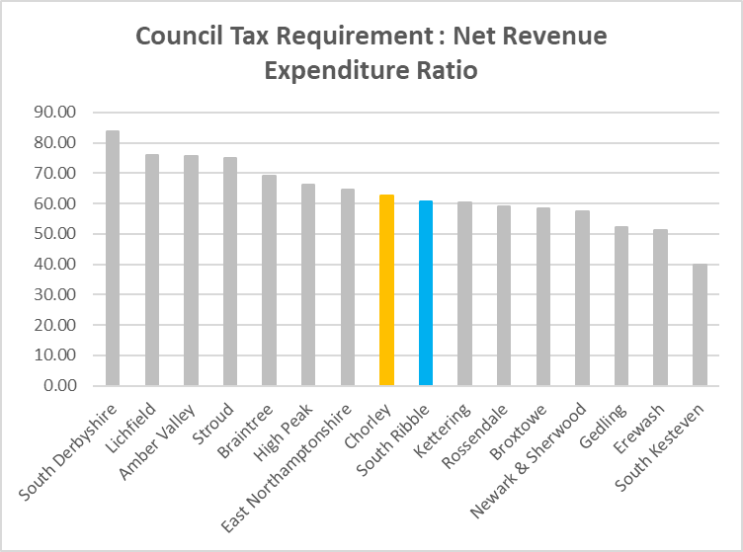

The graph above shows the level of Net Revenue Expenditure funded by Council Tax; the lower the percentage, the higher the dependency on government funding.
The Council has fallen back slightly in percentage terms since 2019/20, however now shows a stronger ranking in the Group.

- Growth Above Baseline

2020/21 | 2019/20
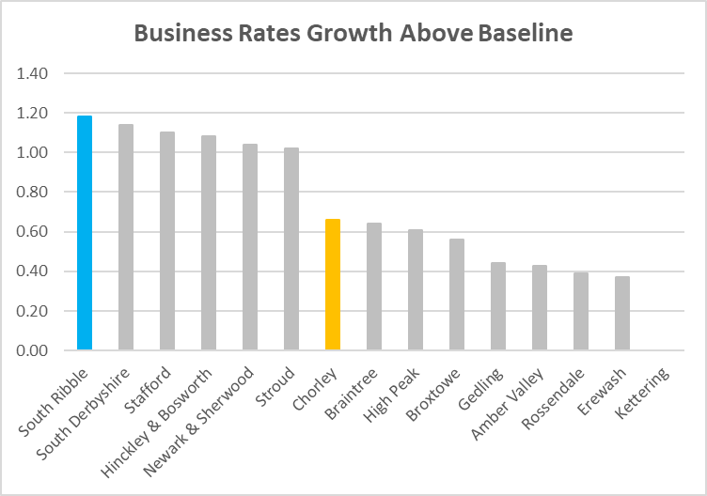 | 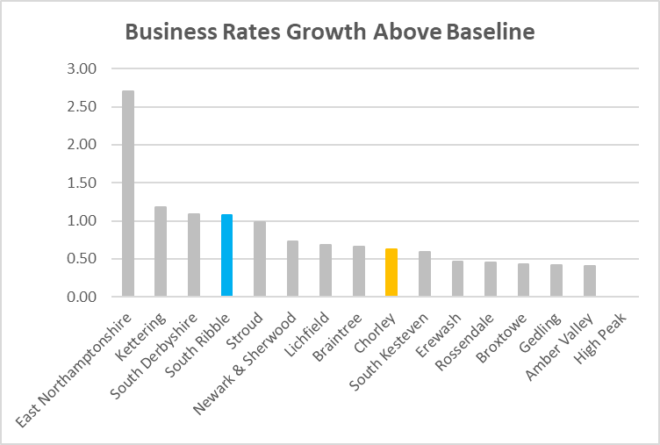

The Council now tops the group; this is due to new developments in the Borough in 2020/21, notably a new Tesco Superstore in Penwortham.

